|  |
| --- |
| **Bush beans, 9** |

|  |
| --- |
| **Pole Beans, 8** |

|  |
| --- |
|  |

|  |
| --- |
|  |

|  |
| --- |
| **Cabbage, 1** |

|  |
| --- |
|  |

|  |
| --- |
|  |

|  |
| --- |
| **Pole Beans, 8** |

|  |
| --- |
| **Beets, 16** |

|  |
| --- |
|  |

|  |
| --- |
|  |

|  |
| --- |
|  |

|  |
| --- |
|  |

|  |
| --- |
| **Pole Beans, 8** |

|  |
| --- |
| **Beets, 16** |

|  |
| --- |
|  |

|  |
| --- |
|  |

|  |
| --- |
|  |

|  |
| --- |
|  |

|  |
| --- |
| **Pole Beans, 8** |

|  |
| --- |
|  |

|  |
| --- |
|  |

|  |
| --- |
|  |

|  |
| --- |
|  |



**Carrots, 16**



**Carrots, 16**



**Carrots, 16**



**Carrots, 16**

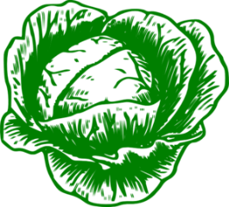

**Cabbage, 1**



**Cabbage, 1**



**Cabbage, 1**

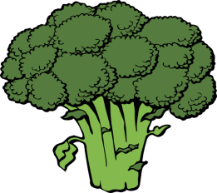

**Broccoli, 1**

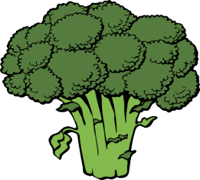

**Broccoli, 1**



**Broccoli, 1**



**Broccoli, 1**

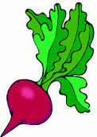

**Beets, 16**



**Bush beans, 9**



**Bush beans, 9**



**Bush beans, 9**



**Beets, 16**